HSN Dropship Tool v1.1 for Accounting Use

Open the HSN Dropship Tool. The most up to date version of the tool can always be found in the HSN EDI directory (\\OPERATIONS\Users\Public\Dropship\HSN\EDI).

**How to generate an invoice upload.**

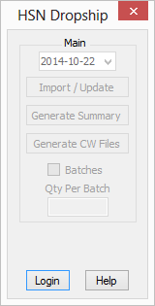1. Notice how only the Login and Help buttons are active. Click on Login to bring up the password prompt.  
Fig. 1 Main Form

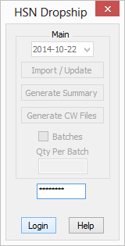2. Type the password that was given to you here and click Login when you are finished. If the password is incorrect the password area will change back to being blank after you hit login.  
Fig. 2 Login Area

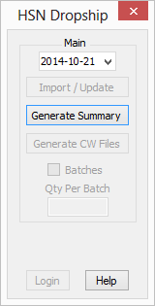3. After successfully logging in, you will have two additional options appear. You will be able to change the date (which refers to ship-date) and also click on the Generate Summary button. Select the date in which the shipments were processed and shipped.   
Fig. 3 Post Login Page

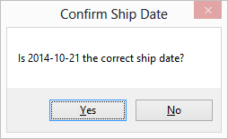4. If the date matches the date that you wanted to generate an invoice for, click yes. Otherwise click no and repeat from step 3.  
Fig. 4 Ship Date Confirmation

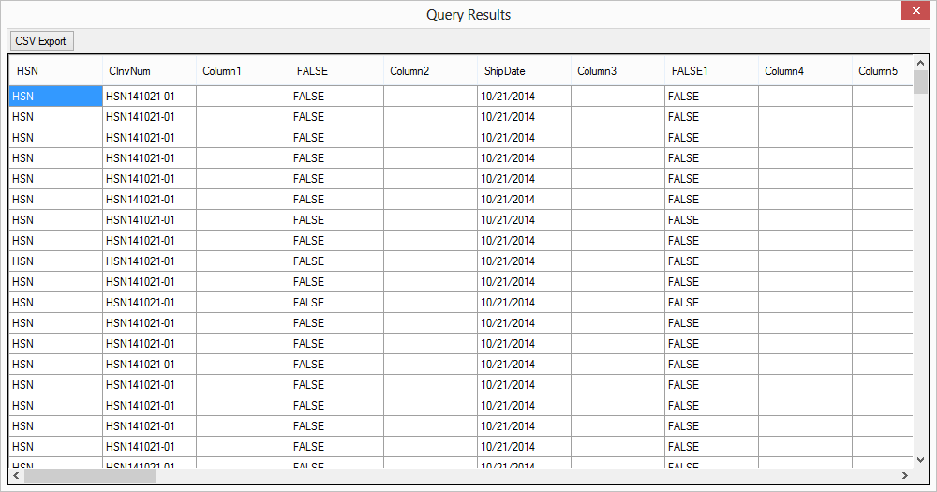Fig. 5 Invoice Upload Result

5. You could either select all of the cells (Which I would not recommend) and paste it into a CSV file or you can click on the CSV Export button on the top left (Which you can see in the next figure, Fig 5.1)

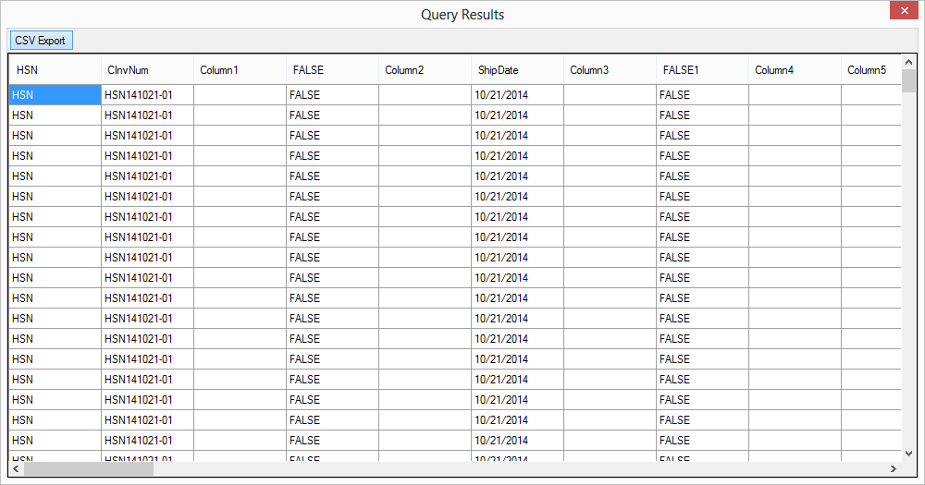Fig. 5.1

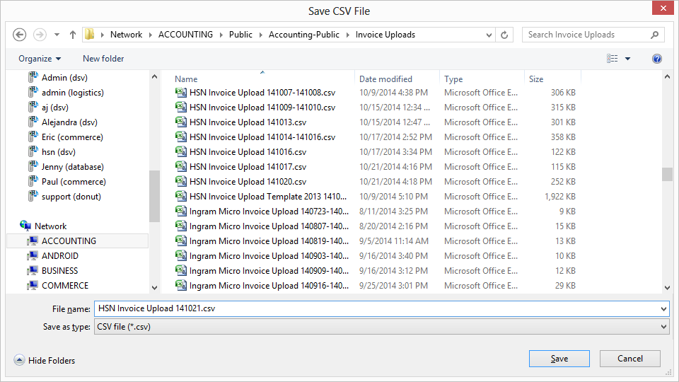Fig. 6 Save CSV File

6. After clicking on the CSV Export button, a save file dialog will appear. Find the directory that you wanted to save the invoice upload, name the file, and click save.

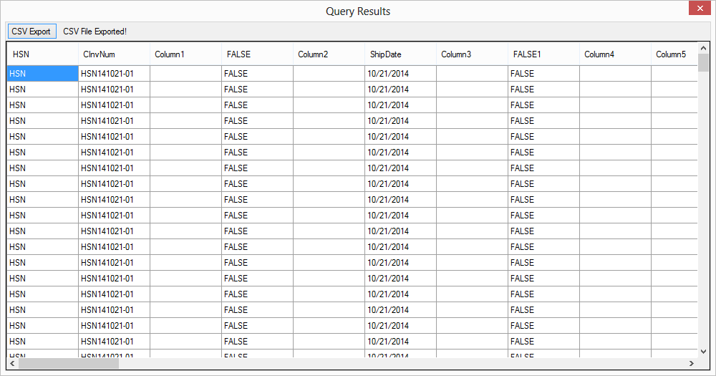Fig. 7 Invoice Upload Export Success

7. If the export was successful, you'll see text that states "CSV File Exported!" on the right side of the CSV Export button.